COME AND JOIN US

Our friendly group has been part of the social scene of St Paul’s for years - we meet from 10.15 until about noon every Tuesday in our small hall.

Anyone in the local community is welcome to join us on a regular or occasional basis & share in friendship.

We have a varied programme (see overleaf) with talks, craft sessions and, outings, and we also support church activities - open days, lunches and other welcoming and community events.

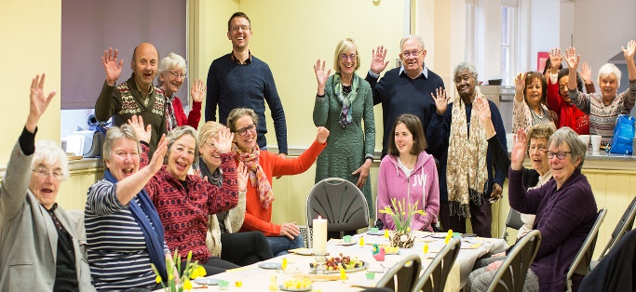

Membership of St. Paul’s Guild is open to all. New members, men and women, are welcome throughout the year. The annual subscription is £10 which runs through to September each year, plus a contribution for refreshments when we have external speakers.

Guests are welcomed for a voluntary charge of £2.00 to cover costs

HOW TO FIND US
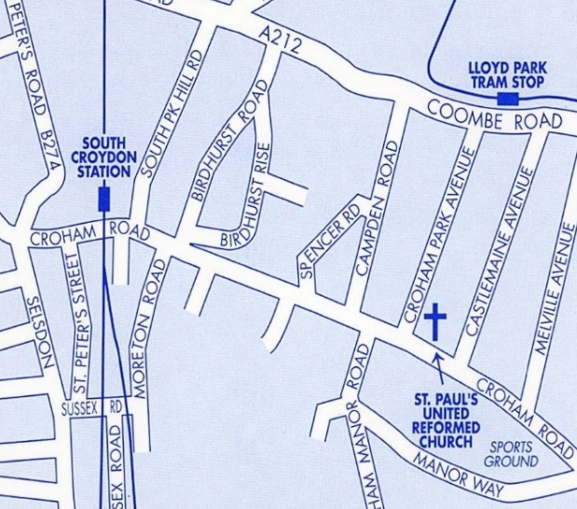

By Bus: Nos. 64; 433 from Selsdon or East Croydon; Stop called
‘St Paul’s United Reformed Church’ is outside

By Tram: Lloyd Park stop is 7 mins walk

By Train: South Croydon is 9 mins walk.
From East Croydon, take tram towards New Addington or bus above for Selsdon/Addington

By Car: We have parking for about 12 cars, or in nearby streets

St Paul’s
United Reformed Church
Croham Park Avenue
South Croydon
CR2 7HF
‘All are welcome’

Tuesday Guild
at St Paul’s
United Reformed Church

Programme – Summer 2022

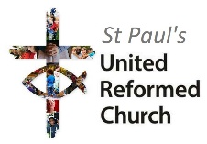
www.stpaulsurc.org.uk
www.facebook.com/stpaulsurc

Croham Road
corner of Croham Park Avenue
South Croydon CR2 7HF
07971 068887 –Sue - Church Secretary

St Paul’s Guild Programme summer 2022
Talks start at 10.30. Refreshments from 10.15.
Summer coffee mornings (July-August) please call for locations
5th and 19th July, Martin and Eleanor
2nd and 16th August Jean (tbc) and Caroline or Christine
30th August, Fran, 13th September Church Garden.

September 2022
20th Our Welcome Meeting – Presentation of the programme
27th Craft and Natter
October 2022
4th Dinosaurs at Crystal Palace with Sarah Jayne
11th The Forgotten Blitz – with Ian Castle
18th Guild outing – location tbc
25th Craft and Natter
November 2022
1st London Walk Online – topic tbc – Andrew Warde
8th Edward VIII and Mrs Simpson with Elizabeth Lanyon
15th Carriage Diving through the ages
22nd Craft and Natter
29th Oberammergau with Eleanor Redshaw and Sue Eardley
December 2022
6th Weather Lore with Ian Currie
13th Christmas Miscelleny
Break for Christmas
January 2023
3rd TBC new year programme starts.

Further copies of the programme are available from the Church Secretary, Sue Eardley, on 0797168887 or Secretary@StPaulsURC.org.uk
Or see our website or Facebook pages for up-to date details www.stpaulsurc.org.uk or www.facebook.com/stpaulsurc

